Xprog2 to SmartProg2 upgrade kit
(order no. 60-0048)

Description

The Xprog2 to SmartProg2 upgrade kit allow the specialized programmer MEMprog2, T51prog2 and PIKprog2 have all features of universal programmer SmartProg2.
The Xprog2 to SmartProg2 upgrade kit is designated for users of T51prog2, PIKprog2 and MEMprog2 programmers, for which is insufficient the range of supported devices of their specialized programmers.
The operation of the upgrade of MEMprog2/T51prog2/PIKprog2 programmer into SmartProg2 consist of the insertion of the Xprog2 to SmartProg2 upgrade pod into the connector on the board of the upgraded programmer (by detailed how-do-it manual). This operation can be done by programmer's user directly (there is not needed to perform upgrade in the Elnec service center).
Important notes:
- the warranty of the MEMprog2/T51prog2/PIKprog2 programmer is not increased to SmartProg2 warranty by installing of this Xprog2 to SmartProg2 upgrade kit.
- the warranty of the MEMprog2/T51prog2/PIKprog2 programmer is not affected by installing the Xprog2 to SmartProg2 Upgrade, but the damage of programmer during self-installation is - of course - not covered by warranty.

Specification

Limitations
- Xprog2 to SmartProg2 upgrade kit is applicable to MEMprog2, T51prog2 and PIKprog2 programmers only

Xprog2 to SmartProg2 upgrade kit contain
- Xprog2 to SmartProg2 upgrade pod
- sticker "Upgraded to SmartProg2"
- installation manual

Installation Manual
- remove supply and USB cables from the programmer
- place the programmer on the bench in such a way that the ZIF socket lever points to you
- unscrew the two screws from the bottom edge of the front side of the programmer, the screws store in a box
- turn the programmer so, that the connectors may point to you
- unscrew the two screws from the upper edge of the rear side of the programmer, the screws store in a box (use - preferable - the same box ;-))
- turn the programmer so, that the ZIF socket lever points to you
- move the ZIF socket lever to the upper position
- carefully lift the upper cover of the programmer
Recommended procedure: Push your right hand thumb against the ZIF socket and lift up the cover by fingers resting on the front side of the programmer. Be careful, because close to the left edge of the upper cover there is a faston with an earthing cable connected!
- turn the upper cover of the programmer left of the programmer and put it on the bench upside down
- insert the X2prog Upgrade pod into the connector on the programmers board (see pictures for more details)
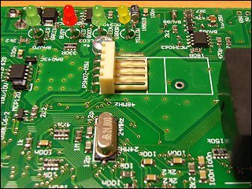 | 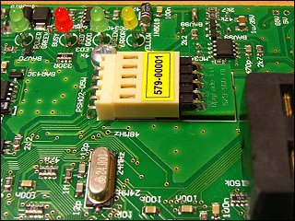
- shut the upper cover by tilting it down on the programmer. Check the LED and the YES button for correct position!
- screw on the two screws at the bottom edge of the programmer front face
- turn the programmer so, that connectors point to you
- screw on the two screws at the back side of the programmer
- place the sticker "Upgraded to SmartProg2" over the MEMprog2/T51prog2/PIKprog2 stamp
- insert USB and supply cables into the programmer
- run PG4UW control software and let it to find SmartProg2 programmer to finish upgrade X2prog to SmartProg2 programmer

Warning
- the Xprog2 to SmartProg2 upgrade kit could be used only for one programmer, once the kit is installed it can not be used for another programmer!

Service centers
- if you're not sure with installation of this upgrade kit, contact please your distributor or ELNEC directly

